NIR-to-RGB Video Colorization:
Temporal Consistency Strategies for the FLAIC Model

Deployment on Jetson Nano

DATASET USED:

S. No. | Dataset | Link | Details | Dataset Exploration | Sample image Details
1 | IDD-AW | https://idd.insaan.iiit.ac.in/dataset/download/ | Adverse-weather Indian driving dataset for autonomous driving research. | • 5000 RGB-NIR pairs  • Resolution: 1024 x 1024  • Weather: rain, fog, low-light  • Scenes: urban roads, highways  • Annotated for scene understanding | Driving scenes captured under adverse weather conditions such as rain, fog, snow, and low-light environments. Contains roads, vehicles, pedestrians, and roadside infrastructure with paired RGB and NIR images.
2. | Pixel-Alligned | https://github.com/divisonofficer/Pixel_aligned_RGB_NIR_Stereo | RGB–NIR Stereo Dataset | • 20,873 RGB-NIR pairs  • Resolution: 1440 x 1080  • Scenes category: well lit, dark, complex | Well lit, Dark, Complex outdoor and indoor scenes
3. | RANUS | https://drive.google.com/file/d/1WJ7rcCeMBPy9Qb2c_pwI0rUIlFqotkzT/view  (not complete, only 4000 images) | RGB-NIR urban scene dataset for cross-spectral learning. | • 4000 paired images  • Classes: 22  • Urban environments  • Roads, buildings, vehicles  • Good RGB-NIR correspondence | Urban road scenes with trees, sidewalks, vehicles, and street infrastructure. RGB–NIR image pairs are well aligned, and vegetation appears brighter in NIR images. Semantic segmentation masks are also provided.

SAMPLE IMAGES:

S. No. | Dataset | NIR | RGB | Type
1. | IDDAW | 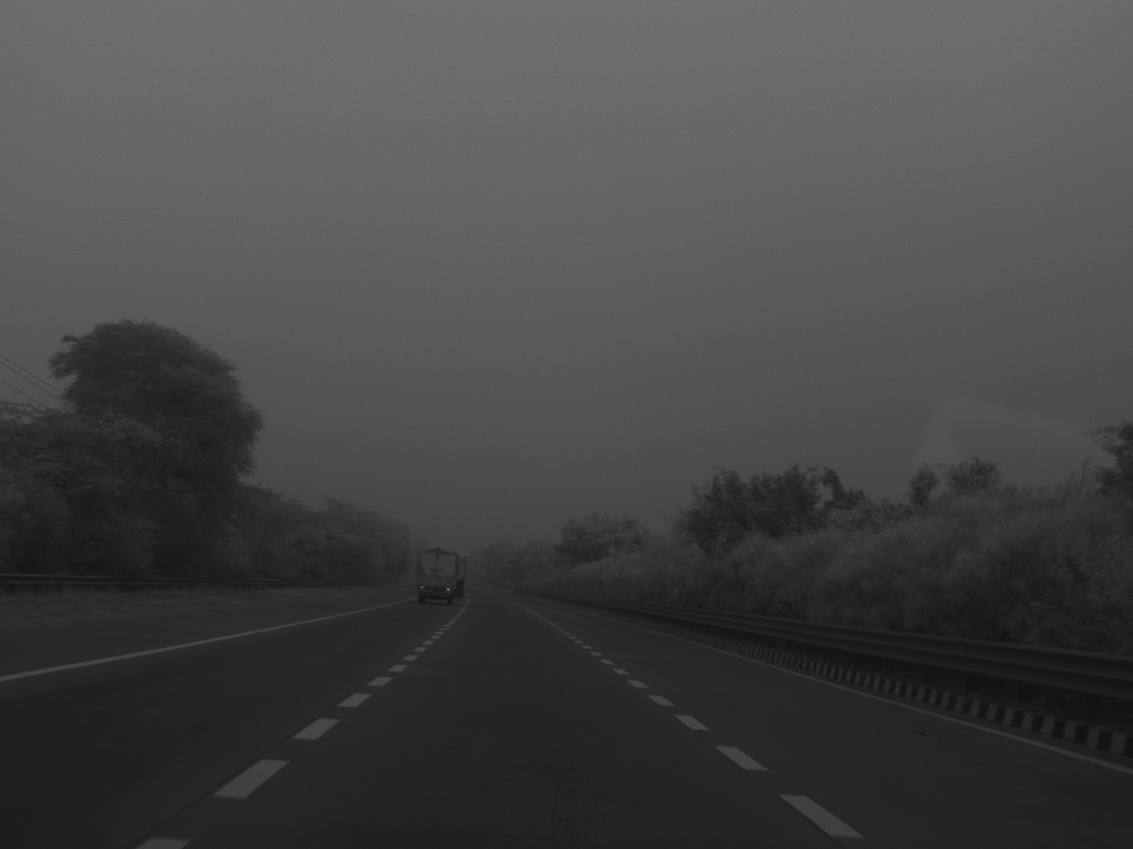 | 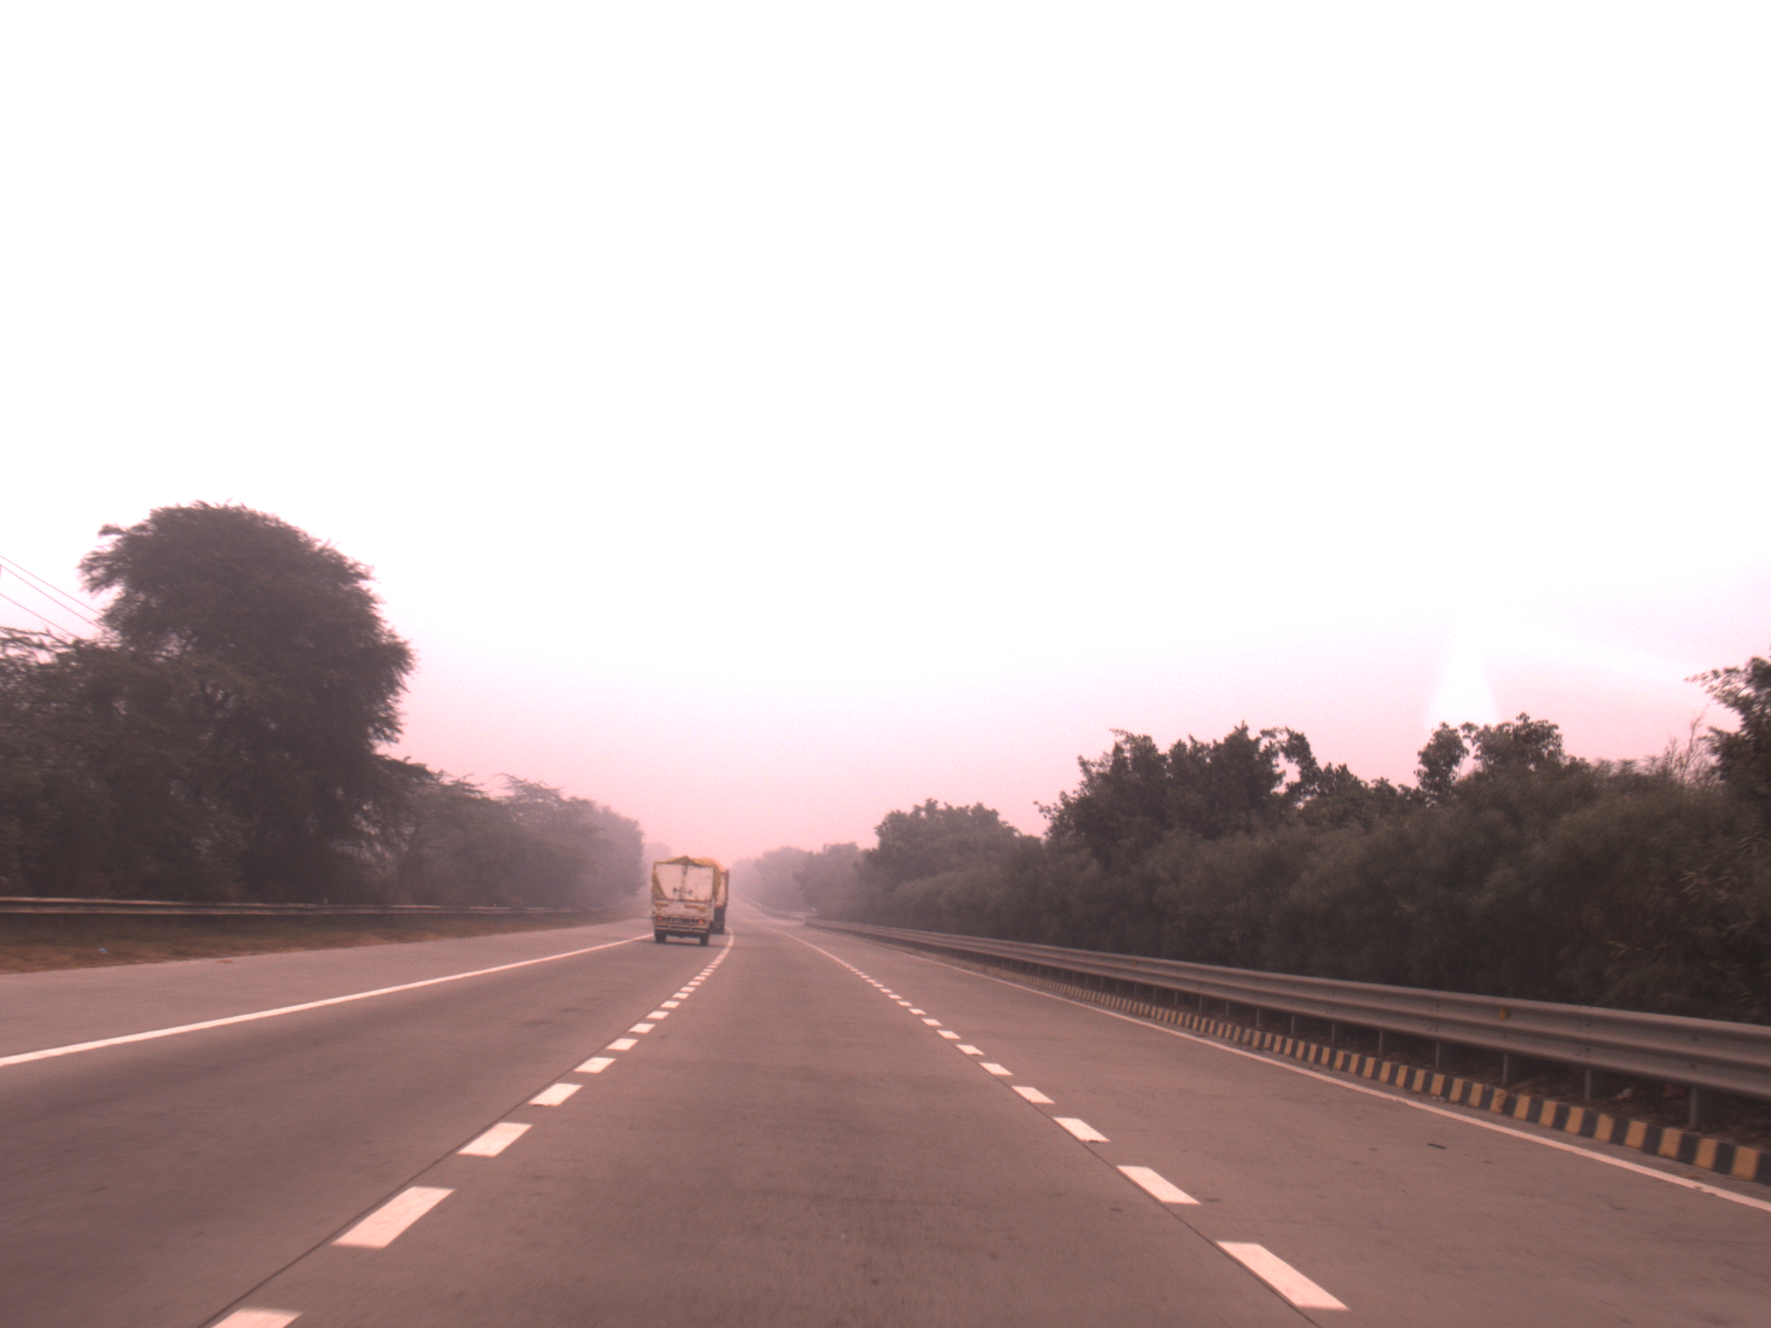 | Video dataset  (paired)
2. | RANUS | 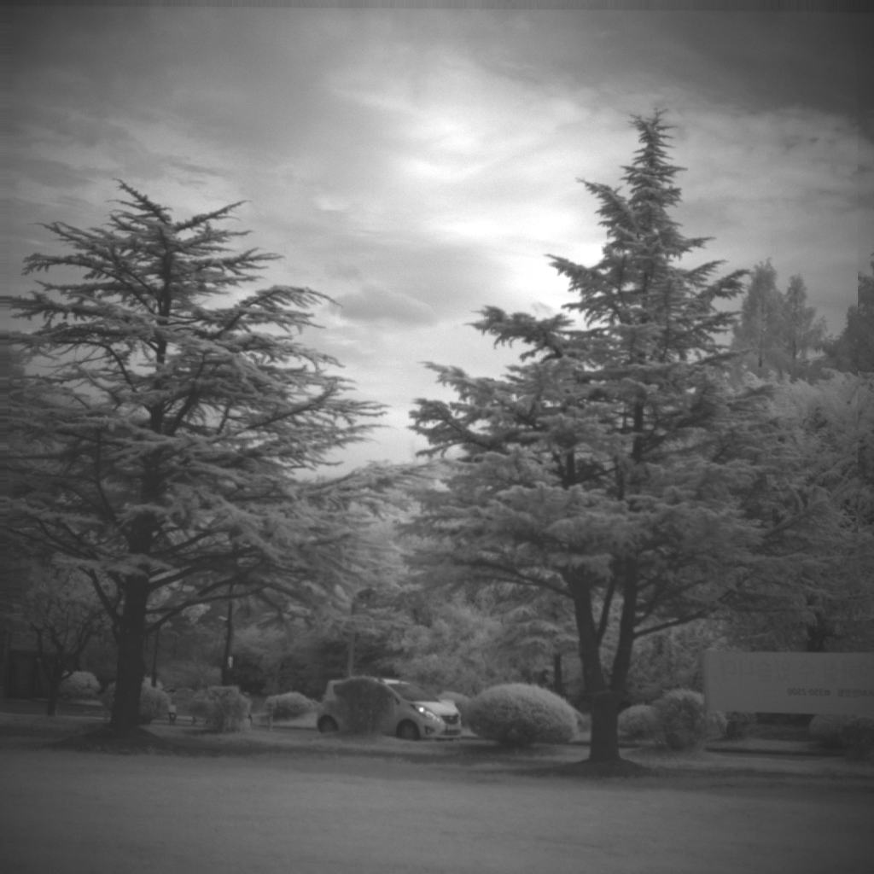 | 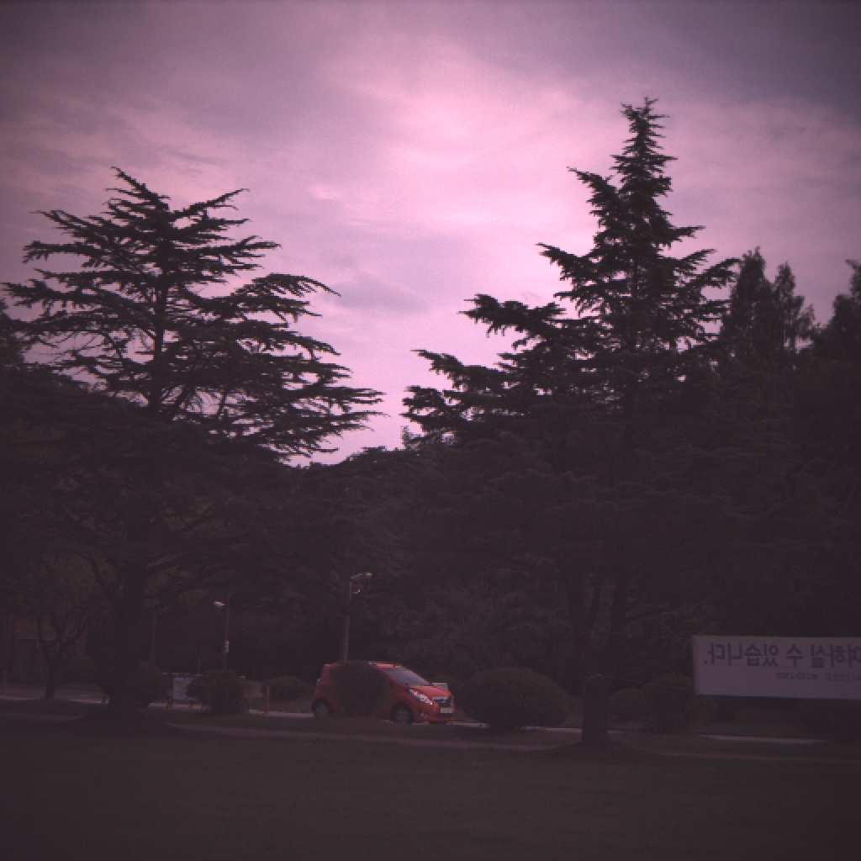 | Video dataset  (paired)
3. | Pixel-Aligned | 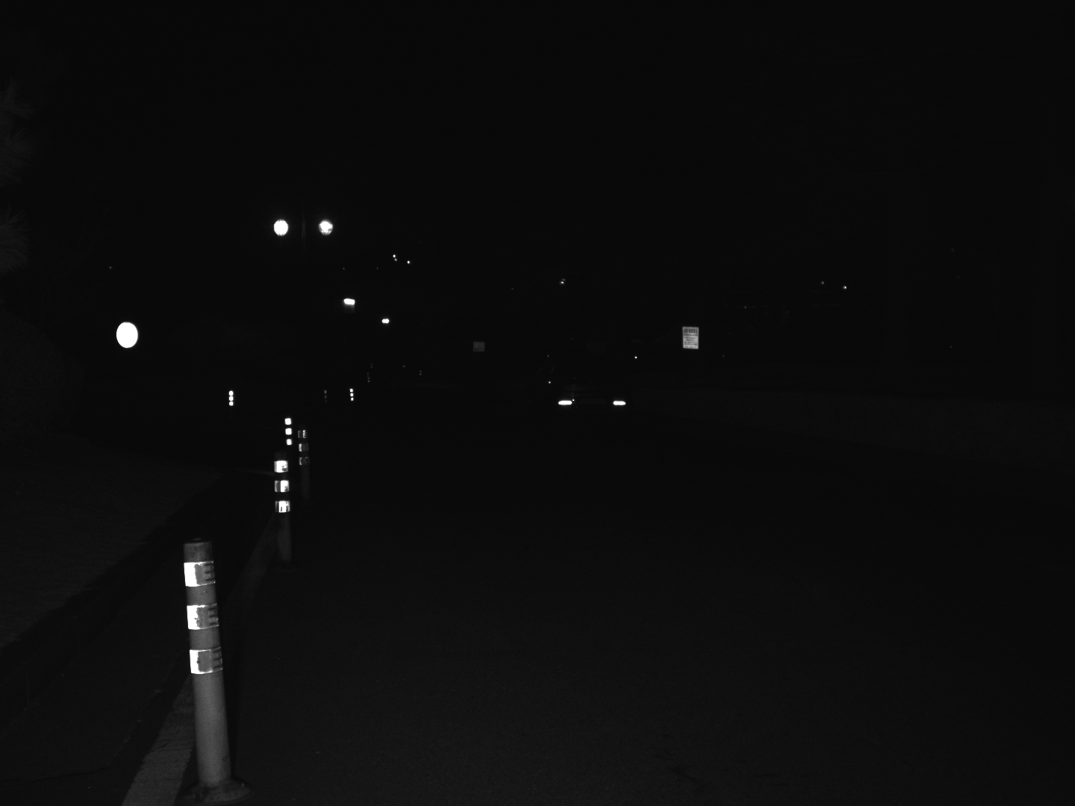 | 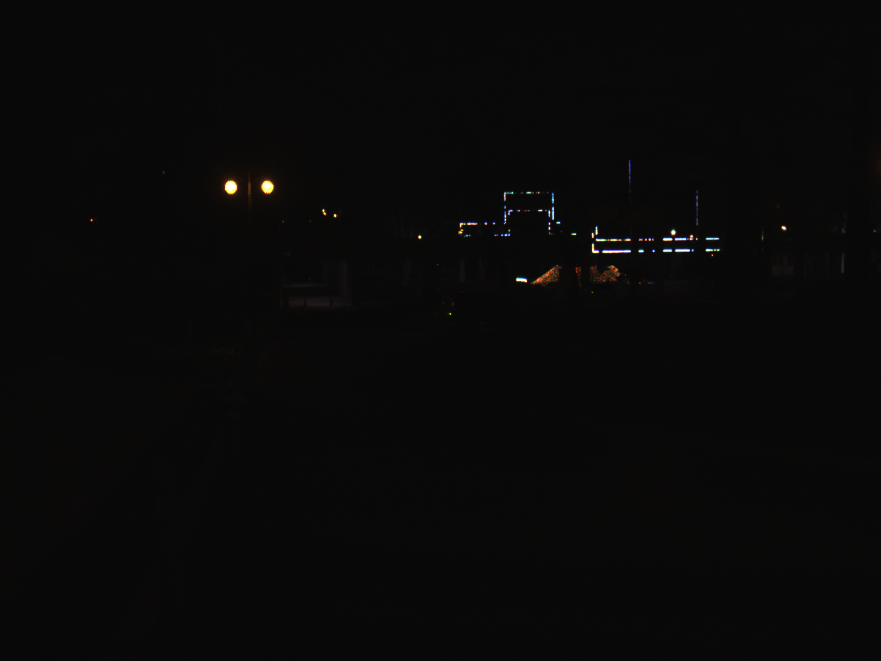 | Video  (Stereo dataset containing left-right NIR-RBG pairs for each frame)

Literature Review:
1. Introduction
Near-Infrared (NIR) imaging captures reflected radiation in the wavelength range of approximately 700–1000 nm. NIR cameras are widely used in night vision, surveillance, autonomous driving, agriculture, remote sensing, and medical imaging because they can operate under low-light conditions. However, NIR images are typically grayscale and lack the visual information present in RGB images, making interpretation difficult for human observers.
- Early methods used Convolutional Neural Networks (CNNs) to learn direct NIR-to-RGB mappings but often produced blurry and less realistic outputs.
- Generative Adversarial Networks (GANs) improved color realism, texture preservation, and visual quality compared to CNN-based approaches.
- CycleGAN-based methods enabled colorization using unpaired NIR and RGB datasets, reducing dependence on aligned image pairs.
- Attention-based networks enhanced semantic understanding and feature fusion, leading to more accurate color prediction.
- Transformer-based models captured long-range dependencies and global scene context, improving semantic consistency and color fidelity.

HAQAGen (2026) - Checks color distribution match |
HAQAGen is a NIR-to-RGB colorization framework that improves color realism and texture preservation using histogram-based color alignment,
HSV-guided color priors, - hue, saturation- random color shift avoided
and perceptual feature losses. It also supports adaptive-resolution inference for high-resolution images. For our FLAIC model, the histogram loss and HSV auxiliary branch could be incorporated to improve color consistency and generate more realistic RGB outputs. However, the method does not address temporal consistency and is designed primarily for image colorization.
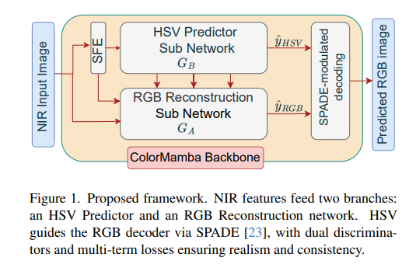
LOSS EQUATION:
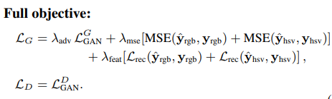

TCVC (2021) - stability of colors over time
TCVC is a video colorization framework that focuses on reducing flickering and improving temporal consistency through bidirectional feature propagation (uses t-1, t, t+1) and temporal self-regularization (loss if colours not matching). Its feature propagation and temporal loss mechanisms are highly relevant to our FLAIC-based video colorization system. These ideas can be combined with Gated Temporal Feature Memory to produce smoother and more stable NIR-to-RGB video outputs.
Framework:
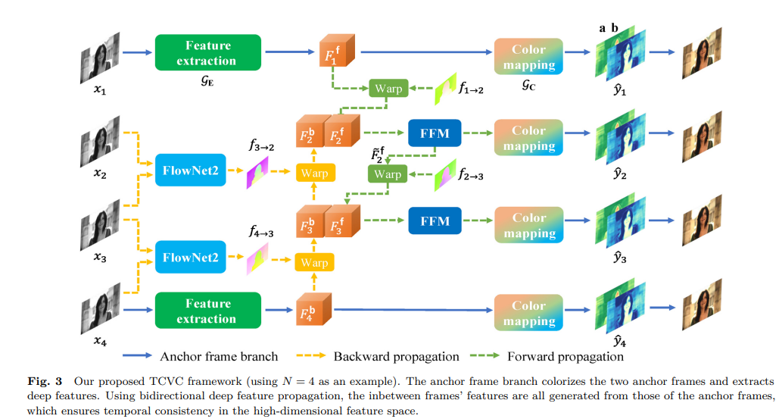
Temporal Warping Loss(Self-regularisation loss):
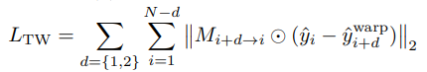

Research Gap:
Original FLAIC

Advantages of the FLAIC Frame-by-Frame Approach
- Simple Architecture
  - Each frame is processed independently, making the model easy to design, train, and deploy.
- Lower Computational Cost
  - No temporal modules (LSTM, ConvLSTM, optical flow, transformers) are required, reducing memory and processing requirements.
- Fast Inference
  - Suitable for real-time applications and edge devices such as the NVIDIA Jetson Nano.
- High Image Quality per Frame
  - The model focuses entirely on generating the best RGB output for the current frame without needing information from previous frames.
- Robust to Frame Loss
  - Since frames are independent, missing or corrupted frames do not affect subsequent outputs.
- Easy Training
  - Requires only paired NIR-RGB images rather than complete video sequences with temporal annotations.

Disadvantages of the FLAIC Frame-by-Frame Approach
- Temporal Flicker
  - Colors may change slightly between consecutive frames even when objects remain unchanged, leading to noticeable flickering in videos.
- No Temporal Consistency
  - The model has no memory of previous color decisions and cannot enforce stable colors across frames.
- Sensitivity to Noise
  - Small changes in NIR intensity caused by sensor noise, lighting variations, or camera movement can result in different color predictions.
- Unstable Object Appearance
  - Static objects (cars, buildings, roads, trees) may appear to change color over time despite remaining unchanged in reality.
- Poor Video Quality Perception
  - Even if individual frames look good, flicker can make the overall video appear unrealistic and distracting.
Most NIR to RGB video colourisation models lack temporal consistency, and use heavy optical flow. Optical flow reduces PSNR, SSIM and adds latency which increases computational complexity making it harder to deploy the model on edge devices.
- We need a model which produces high quality results while being temporally consistent.
- It must also be lightweight enough to be deployed on the Jetson Nano.
- Most studies evaluate performance using image quality metrics such as PSNR and SSIM while assuming access to high-performance computing resources.
- Limited attention has been given to the deployment of NIR-to-RGB colorization models on resource-constrained edge devices.
- Comparative evaluation of PyTorch models against optimized ONNX-based implementations is often absent.
Model | What It Does
Previous-Frame Output Blending (Temporal Alpha Compositing) | Reduces flicker by blending the current colorized frame with the previous colorized frame. The blending weight is adjusted according to the amount of scene motion, providing smoother color transitions between frames.
Previous-Frame RGB Conditioning via Input Augmentation | Feeds the previous colorized frame back into the model as additional input channels,FLAIC is extended 8 + 3 previous RGB, allowing the network to use past color information and maintain temporal consistency across consecutive frames.
Deep Video Prior (DVP) | Uses a lightweight CNN as a post-processing step to learn a temporally smoother version of the colorized video. It suppresses flickering by capturing stable scene structures while ignoring frame-to-frame color variations.
Bottleneck Feature Caching with Additive Residual Injection | Stores deep semantic features from the previous frame and injects them into the current frame's bottleneck layer. This encourages consistent color predictions while preserving scene details and motion.
WORK DONE:

Using ONNX (Open Neural Network Exchange) to convert the PyTorch .pth file to the deployable .onnx file.
In NVIDIA Jetson Nano deployments, ONNX serves as an intermediate representation that allows TensorRT to import, optimize, and accelerate neural network inference. This optimization process improves execution speed, reduces memory consumption, and enables the use of reduced-precision computation such as FP16.

https://pytorch.org/blog/running-pytorch-models-on-jetson-nano/
ONNX conversion for Previous RGB conditioning model
- Initial conversion resulted in an FP32 (32-bit floating-point precision) ONNX file, which was 64MB in size.
Used the following methods to reduce file size:
1. FP16 conversion from FP32:
- In FP32 each weight occupies 32 bits of memory.
- Size reduced to 32MB

- To improve inference performance on the NVIDIA Jetson Nano, the model was converted to FP16 (16-bit floating-point precision)

- The ONNX graph was converted to FP16 using the onnxconverter_common.float16.convert_float_to_float16() utility.
- This process traverses the ONNX graph, converts all floating-point weights, biases, and tensor datatypes from 32-bit to 16-bit precision

2. INT8 Quantization of FLAIC (NVIDIA ModelOpt):
- ONNX file with 8-bit integer weights and activations.
- Size reduced to 32MB
- This is a Post-Training Quantization (PTQ) approach — the model is quantized after training .
- A small calibration dataset was used to obtain optimised parameters.
- INT8 quantization is applied using NVIDIA ModelOpt (nvidia-modelopt library)
- IDD-AW dataset was used for calibration — 475 images in total, drawn equally from four adverse condition categories: RAIN, FOG, SNOW, and LOWLIGHT.
https://github.com/NVIDIA/Model-Optimizer/tree/main/examples
https://github.com/NVIDIA/Model-Optimizer/tree/main/examples/onnx_ptq

RESULTS:
 | FP32 | FP16 | INT8
PSNR (must be higher) | 21.571 | 21.572 | 18.392
SSIM (must be higher) | 0.7889 | 0.7890 | 0.7344
LPIPS (must be low) | 0.1598 | 0.1598 | 0.2197

MODEL | SIZE(MB) | RAM(MB) | FPS(GPU) | FPS(CPU) | SPEEDUP
FP32 | 64.6 | 300.2 | 42.85 | 3.84 | 1X
FP16 | 32.3 | 15.5 | 79.75 | 3.94 | 1.86X
INT8 | 32.5 | 29.1 | 69.83 | 2.26 | 1.63X

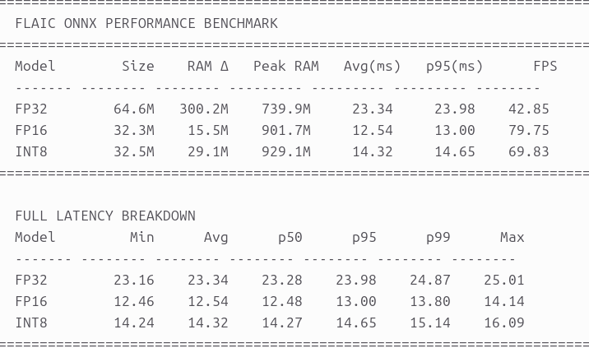

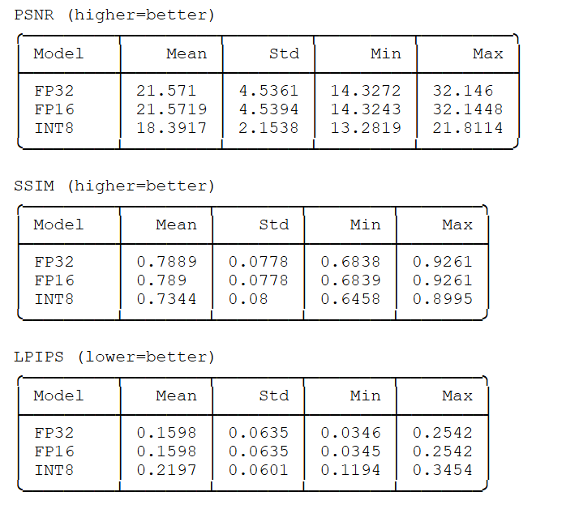
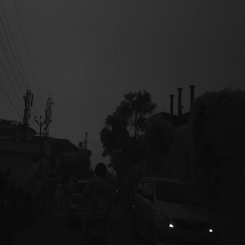 | 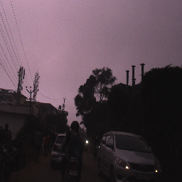
NIR | GT RGB
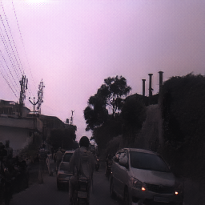 | 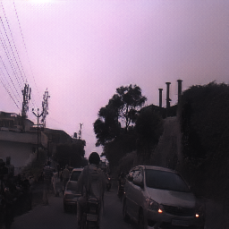 | 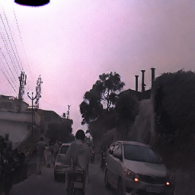
FP32 | FP16 | INT8
LOW-LIGHT CONDITIONS
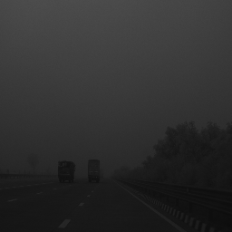 | 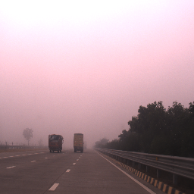 | 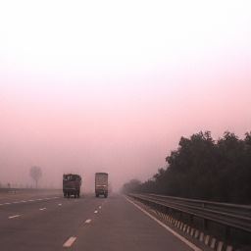
NIR | GT RGB | Pytorch model output
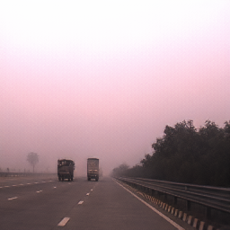 | 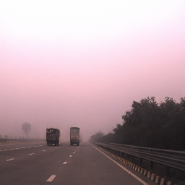 | 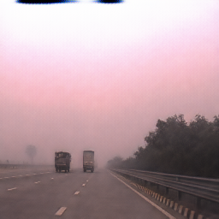
FP32 | FP16 | INT8
FOG CONDITION

CONCLUSION:
- FP16 seems to be the ideal conversion format to be used.
- This is valid for all approaches (models).

Work completed this week:
- Converted previous frame rgb conditioning model to onnx file
- Converted to FP32, FP16, and INT8 onnx files.
- Compared PSNR, SSIM, LPIPS and image outputs.
- Recorded FPS, Size, RAM.

Goals for this week:
FP16 onnx conversion for all models.
Goals for upcoming weeks:
Deploy on Jetson Nano and measure latency, FPS, and memory usage.
Compare output with PyTorch output.

Proposed Model:
- Modify the original FLAIC model to include concepts from HAQAGen

The original FLAIC could colorize individual NIR images reasonably well, but it had weaknesses:
- The global colour statistics were often wrong - the overall feel of the image was too warm or too cool or too washed out, because the model was optimised pixel-by-pixel without any constraint on whether the colour distribution matched reality.
- Local colour consistency was unstable - different parts of the same image could drift to different colour assignments because the decoder had no spatially-specific colour guidance.
- When applied to video or sequential frames, the model flickered.
Problems by integrating ideas from two published papers: HAQAGen for image quality, and a bottleneck feature caching approach inspired by TCVC for temporal consistency.
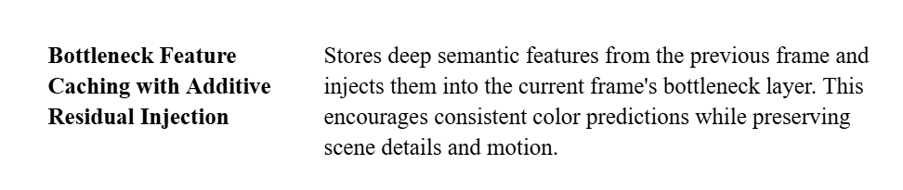
Concepts used from HAQAGen:

HAQAGen concept 1: Dual HSV branch and SPADE
The first major addition is a dual-branch architecture inspired by HAQAGen. We add a lightweight HSV predictor branch, a depthwise-separable CNN of about 4 million parameters that sits on top of the bottleneck and predicts a dense hue-saturation-value map for the entire image simultaneously with RGB prediction.
This HSV map is then injected into the RGB decoder at every resolution level using SPADE (Spatially Adaptive Denormalization). SPADE works by using the predicted HSV map to compute spatially-varying scale and shift factors that are applied to the decoder's feature maps. Concretely, for a decoder feature map F, we compute: F̃ = γ(HSV) × InstanceNorm(F) + β(HSV), where γ and β are learned 1×1 convolutions. The result is that every region of the image receives a colour hint specific to its location.

HAQAGen concept 2 : Differentiable CDF histogram loss
Differentiable histogram loss, which addresses the global colour statistics problem directly.
We implement a soft histogram using a triangular kernel: instead of each pixel being assigned to exactly one bin, it contributes smoothly to nearby bins with weights that depend on distance. This makes the histogram differentiable.
From the soft histogram we compute the CDF for each colour channel separately. We then penalise the L1 distance between the CDF of our generated image and the CDF of the ground truth.

HAQAGen concept 3 : Texture autoencoder and VGG perceptual loss
Texture-aware supervision- We train a small 4-layer autoencoder on our RGB training images, no skip connections, so it must encode genuine texture information to reconstruct well and then freeze its weights. During main training, both the predicted and ground-truth images are passed through this frozen encoder, and we compare the internal features using both L2 distance and cosine similarity. These two terms together capture whether the texture patterns are correct.
Concepts used inspired from TCVC:
Bottleneck feature caching for temporal consistency:
For video sequences, we implement Approach 4: bottleneck feature caching. After the encoder and bottleneck process a frame, we cache the bottleneck feature map—which is 256 channels at 64×64 spatial resolution. When the next frame arrives, we inject a small fraction of the previous frame's cached features into the current frame's bottleneck before the decoder runs:
z̃_t = z_t + β_t × z_{t-1}
where β_t is adaptive. We measure how different the current and previous bottleneck features are, if they're very similar, the scene is static and we allow a large β up to 0.25, giving a strong temporal anchor. If they're very different, indicating fast motion or a scene cut, β drops to zero and the frames are processed independently.
Work done:
- Improved the original FLAIC model code with the above proposed concepts.
- Dataset used for training: Pixel-Aligned
- 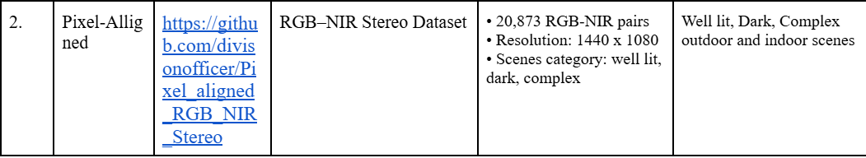
- Ran the model on part of the dataset for epoch=20 to see if the model was working.
- Results:
- 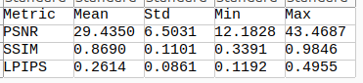
- Update: Made changes to the code and changed the ResBlocks from 12 to 8. Tradeoff between lightweight model and PSNR.
- The updated model is currently training.
Goals for this week:
- Complete training and testing of proposed model
- Compare if this model is better than other models
- Generate onnx files for the best-working model
- Jetson Nano Deployment

Update as of thursday:
- Result of FLAIC + HAQAGen model-
- 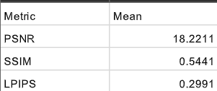
- PSNR drop compared to original FLAIC
- Hybrid FLAIC + HAQAGen model not lightweight enough for Jetson deployment
- Model dropped

Final model

TempNIR2RGB-Lite: Change-Aware Causal Feature Memory for Real-Time NIR-to-RGB Video Colorization
A lightweight causal NIR-to-RGB video colorization model that stabilizes RGB predictions using feature-level temporal memory, NIR change-aware gating, and local memory alignment, without using optical-flow inference at runtime.
Final novelty statement:
We propose a causal feature-memory NIR-to-RGB video colorization framework that learns when to preserve stable temporal color features and when to refresh them from the current NIR frame using a lightweight change-aware gate. Unlike output blending or previous-RGB conditioning, the method propagates compact bottleneck features rather than RGB pixels, reducing flicker while avoiding ghosting and remaining suitable for ONNX/TensorRT edge deployment.

Comparison:
Model | Temporal Information Used | Additional Modules | Advantages | Limitations | Why TempNIR2RGB is Better
Original FLAIC | None | Skip-connection ResNet generator with DWT features (8-channel input) | Simple baseline, good single-frame colorization, lightweight | Frame-by-frame processing causes flicker; no global color constraints | Adds temporal consistency while remaining lightweight.
Adaptive Alpha Blending | Post-processing output blending | Adaptive alpha blending | Easy to implement; reduces flicker in static scenes | Ghosting during motion; does not improve network | Learns temporal consistency using feature memory instead of output averaging.
Previous RGB Conditioning | Previous RGB prediction | 11-channel input (current NIR + previous RGB) | Learns temporal relationships directly | Error accumulation; larger input; higher computation | Uses compact bottleneck features instead of full RGB, reducing computation and error propagation.
Gated Temporal Feature Memory | Cached bottleneck features | Adaptive gating | Preserves semantic temporal information | No explicit global color supervision | Combines lightweight temporal memory with improved color supervision.
Bottleneck Residual Injection | Cached bottleneck residuals | Residual feature injection with stop-gradient and gating | Improved temporal consistency with limited ghosting | No global color modeling | Adds efficient temporal memory while remaining deployment-friendly.
FLAIC + HAQAGen Hybrid | Bottleneck feature caching | HSV branch, SPADE, differentiable histogram loss, texture autoencoder, VGG perceptual loss | Color realism | PSNR drop; model too large for Jetson Nano | TempNIR2RGB provides a much better efficiency–accuracy trade-off.
TempNIR2RGB (Proposed) | Adaptive bottleneck feature caching | Optimized FLAIC (8 ResBlocks), lightweight bottleneck memory | Lightweight, temporally consistent, ONNX/TensorRT friendly, Jetson Nano compatible | Slightly lower perceptual quality than much larger models | Best balance of color quality, temporal consistency, model size, speed, and deployability.

ARCHITECTURE:

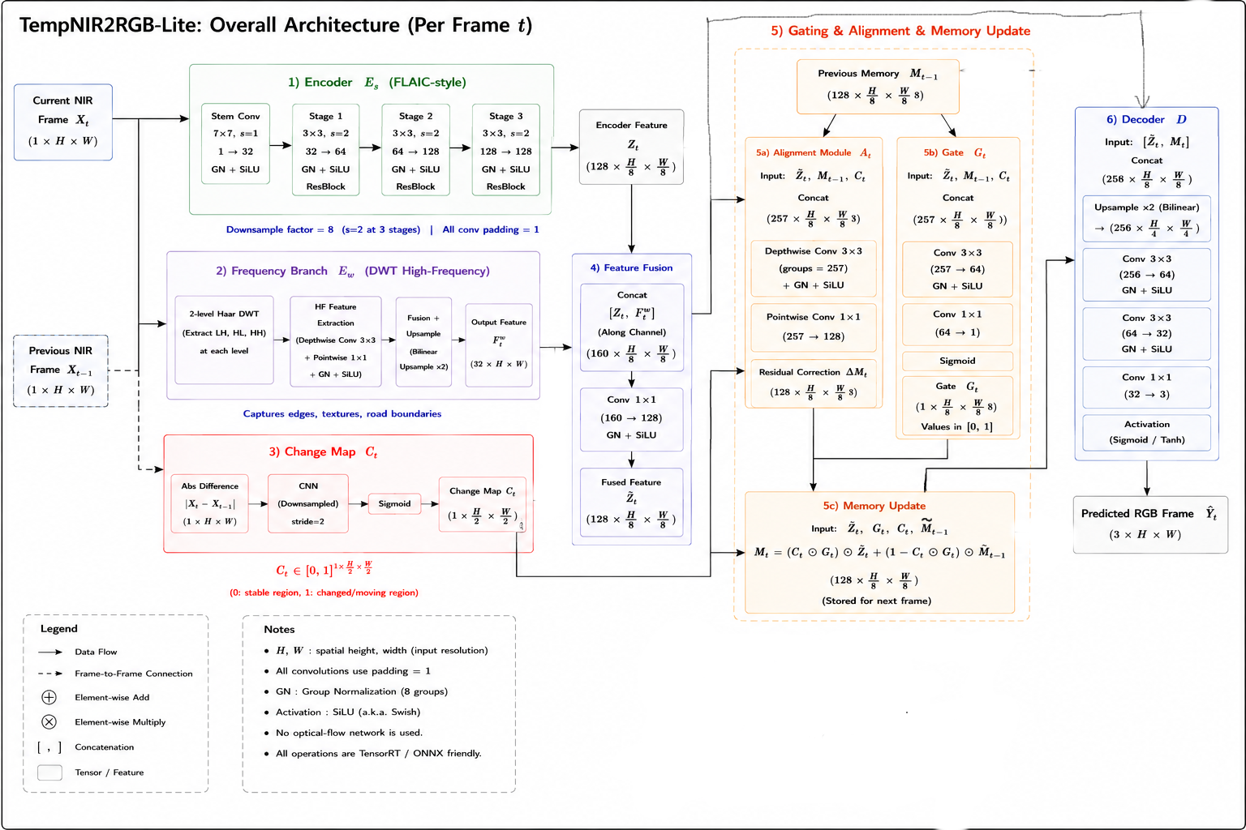
Input:
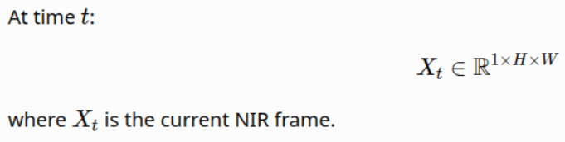
Encoder: FLAIC encoder, gives Zt
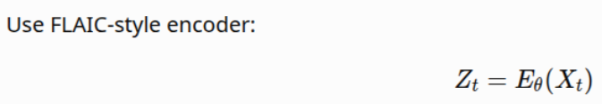
DWT: Apply discrete wavelet transform to the input Xt. Keep only high frequency bands to understand edge and boundary information. Pass the high frequency bands to a small encoder.
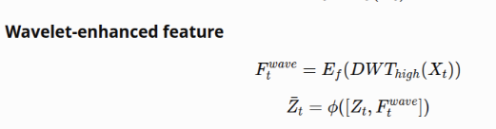
Feature Fusion: Combine encode feature Zt and wavelet feature. Zt bar.
Temporal memory: Initialise memory M0=0. Refresh memory after every sequence.
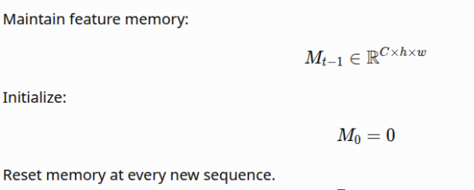
Change map: detect where the scene has changed. Difference between current NIR frame and Previous NIR frame. Pass the downsampled difference through CNN to remove noise.
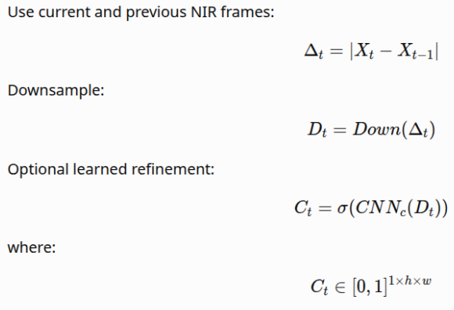
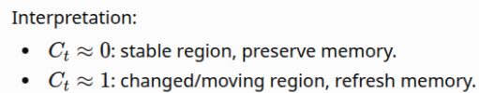
Gate: Decide whether to trust the previous frame or the current frame. Pass previous memory, current features, and change map through CNN
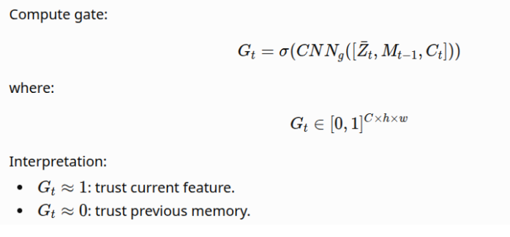

Local Alignment: Correct the previous memory so it aligns with the previous frame.
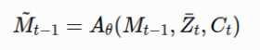
Residual correction ΔM. Aligned memory M_{t-1} + ΔM
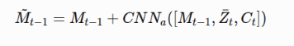
Memory Update:
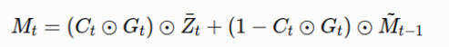
Ct x Gt means both change map and gate conditions must agree.
Decoder: The decoder is UNet-style , it upsamples M_t back to full resolution using skip connections from the encoder stages, so fine spatial detail lost during downsampling is recovered. The final output is a 3-channel RGB image
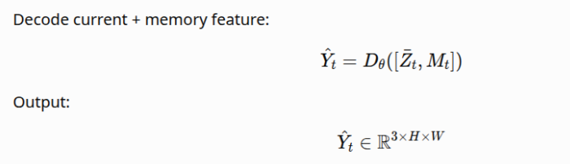

Loss:
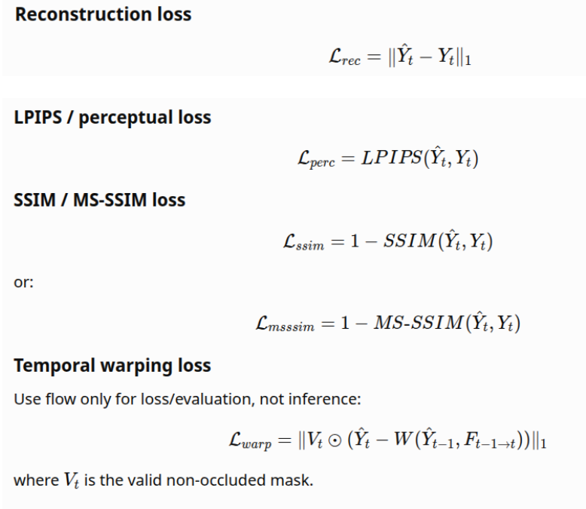
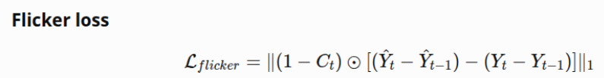
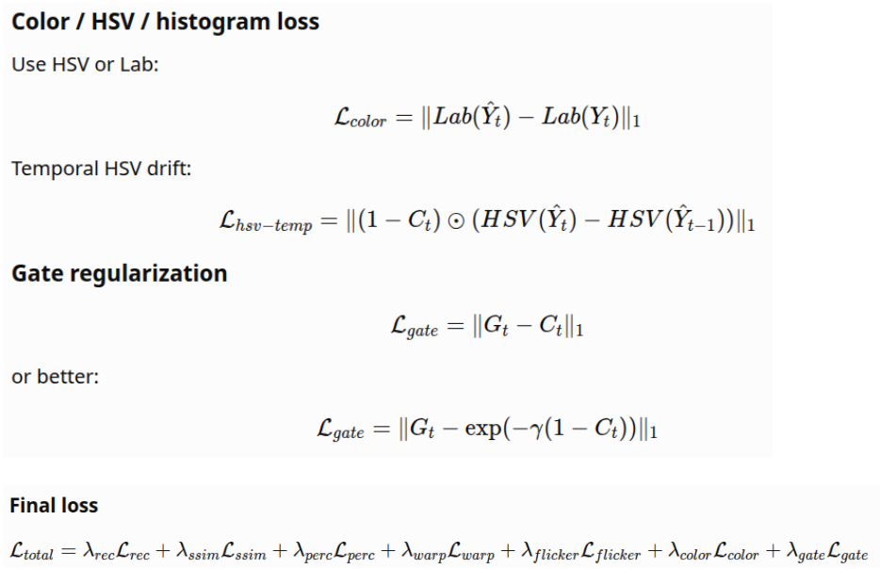
Initial weights:
lambda_rec = 1.0
lambda_ssim = 0.2
lambda_perc = 0.1
lambda_warp = 0.1
lambda_flicker = 0.1
lambda_color = 0.05
lambda_gate = 0.01

Advantages of this architecture:
- Flicker Reduction: The change map identifies regions with little or no motion, allowing the model to reuse previously learned feature representations instead of recolorizing them independently in every frame.

- Avoids Ghosting: Ghosting artifacts are minimized through the combination of the change map, local alignment module, and learned gating mechanism. The local alignment module compensates for small camera and object motions before memory reuse, while the change map detects newly appeared or moving regions.

- Reduced color drift: The memory stores encoder features rather than synthesized RGB images, preventing color prediction errors from accumulating over time.

- Prevention of error accumulation: Previous RGB predictions are never reused as network inputs, the proposed architecture avoids recursive propagation of prediction errors. Each frame is colorized using the current NIR information together with the learned feature memory.

- Eliminates optical flow during inference.

- Real time deployment: Since the architecture does not rely on external optical-flow networks such as RAFT, PWC-Net, or SpyNet, inference requires only lightweight convolutional operations. This significantly lowers latency, memory consumption, and computational complexity.

Training on IDDAW dataset

Model | PSNR ↑ | LPIPS ↓ | Flicker ↓ | tLPIPS ↓ | Color Drift ↓ | InferenceFPS ↑
Frame-wise FLAIC | 21.2556 | 0.2153 | 17.7086 | 0.4748 | 27.3371 | 69.70
FLAIC+Alpha Blend | 20.5683 | 0.2571 | 15.0510 | 0.4140 | 23.8277 | 57
Previous RGB Conditioning | 22.1436 | 0.2119 | 16.9177 | 0.4797 | 5.3149 | 54.64
Direct Feature Injection | 21.2556 | 0.2153 | 17.4642 | 0.4772 | 5.4503 | 57.83
Gated Temporal Memory | 21.1791 | 0.2160 | 16.8850 | 0.4686 | 21.5285 | 46.82
WITHOUT TEMPORAL WARPING ERROR (without optical flow during inference):

Parameters =1535250
TempNIR2RGB | 21.5837 | 0.2425 | 13.16 | 0.4061 | 0.0433 | 65.862

Performance by weather
Weather | Avg PSNR | Avg SSIM | Avg LPIPS | n_sequences
fog | 23.81 | 0.905 | 0.173 | 7
lowlight | 21.34 | 0.846 | 0.250 | 8
rain | 20.71 | 0.806 | 0.286 | 5
snow | 17.84 | 0.685 | 0.342 | 3

ABLATIONS:

VARIANT | PARAMETERS | PSNR | SSIM | LPIPS | tLPIPS | ColorDRift | Flicker | TrainingFPS
NO GATE | 1387153 | 21.55 | 0.8312 | 0.251 | 0.4035 | 0.047 | 0.1235 | 71.27
NO CHANGE | 1534733 | 21.77 | 0.8376 | 0.246 | 0.4016 | 0.044 | 0.125 | 66.03
NO ALIGN | 1482121 | 21.51 | 0.8353 | 0.252 | 0.3974 | 0.045 | 0.1231 | 70.45
NO WAVELET | 1450194 | 20.86 | 0.8286 | 0.258 | 0.399 | 0.051 | 0.1265 | 70.04

AT INFERENCE: without optical flow
Variant | PSNR ↑ | SSIM ↑ | LPIPS ↓ | Flicker Index ↓ | TWE ↓ | tLPIPS ↓ | Color Drift ↓ | Ghosting ↓ | FPS ↑ | Latency ms ↓ | Model MB ↓ | Params M ↓ | FLOPs G ↓ | GPU Mem ↓ | RAM ↓
TempNIR2RGB-Lite Final | 19.92 | 0.8063 | 0.247 | 0.1597 | Nan | 0.4491 | 0.0526 | 0 | 65.8 | 15.18 | 6.17MB | 1535250 | 69.67 | 348.27 | 1702.26
Final w/o Gate | 19.91 | 0.802 | 0.257 | 0.155 | nan | 0.452 | 0.056 | 0 | 71.66 | 13.95 | 5.58 | 1387153 | 64.81 | 346.5 | 2505.13
Final w/o Change Map | 19.76 | 0.804 | 0.256 | 0.1557 | nan | 0.448 | 0.0582 | 1 | 66.36 | 15.06 | 6.1 | 1534733 | 69.65 | 349.11 | 2505.13
Final w/o Alignment | 20.006 | 0.806 | 0.26 | 0.1558 | nan | 0.447 | 0.053 | 0 | 70.47 | 14.19 | ~6 | 1482121 | 67.92 | 350 | 2505.13
Final w/o Frequency Branch | 19.19 | 0.797 | 0.269 | 0.1659 | nan | 0.453 | 0.0584 | 0 | 70.31 | 14.22 | 5.8 | 1450194 | 66.89 | 346.09 | 2505.13

Sample Images:

FOG
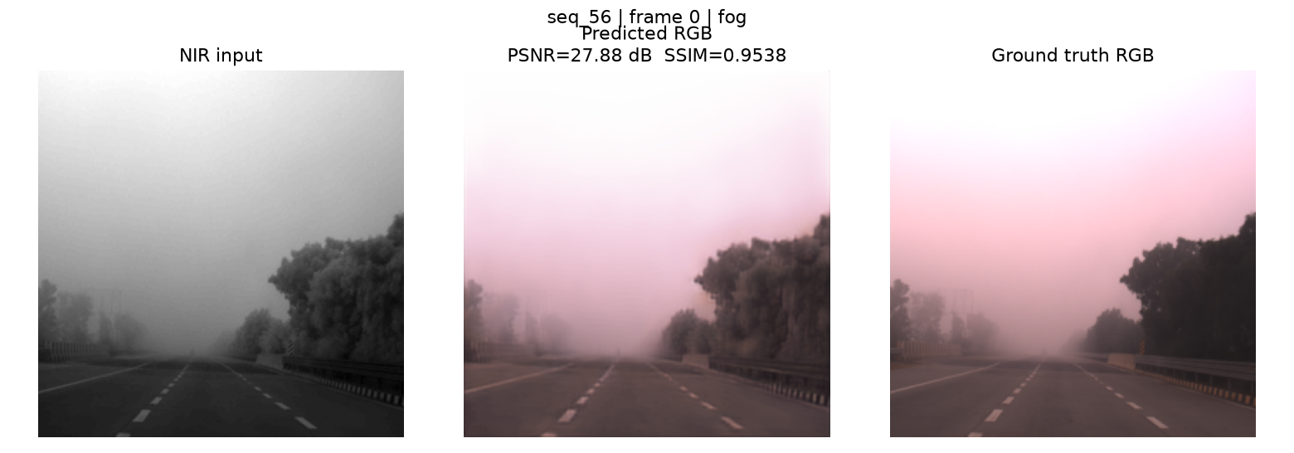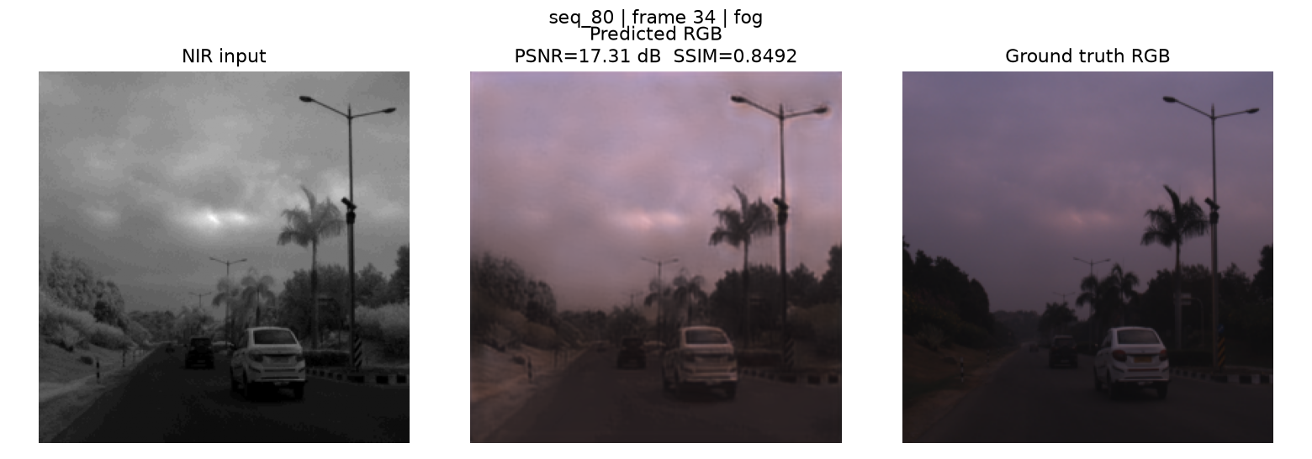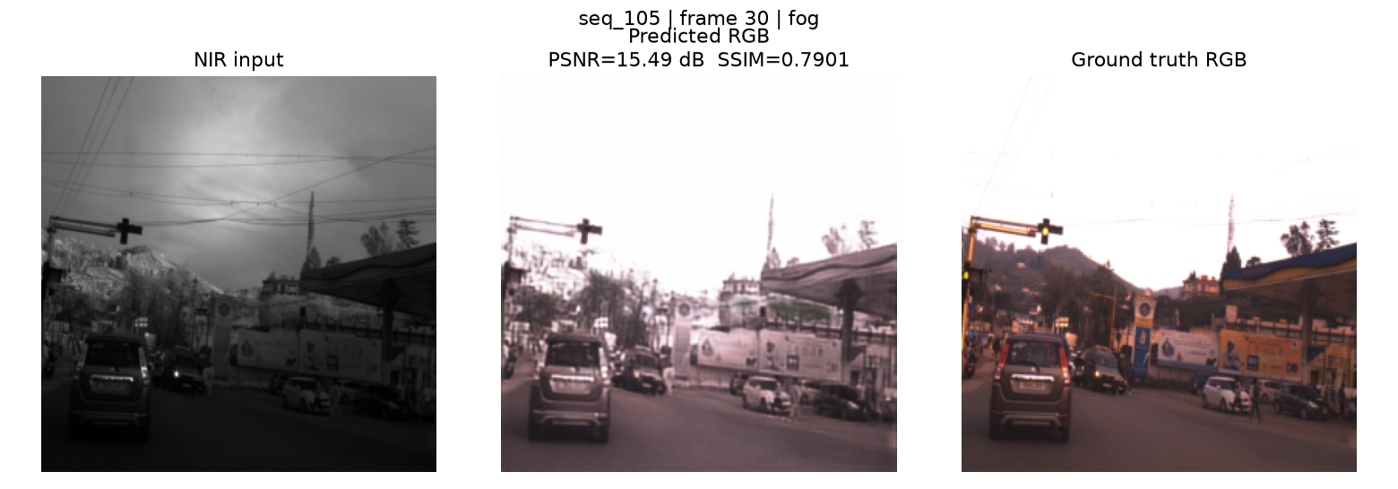

RAIN
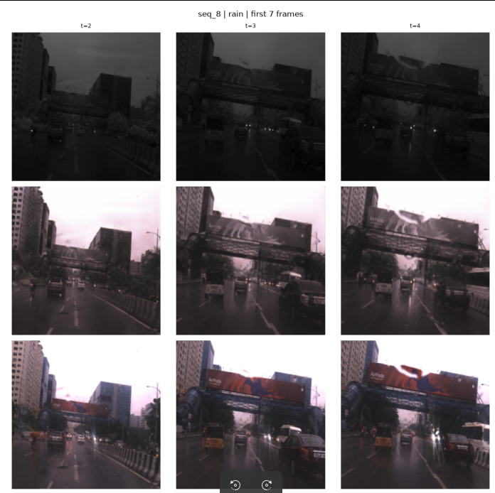
LOWLIGHT

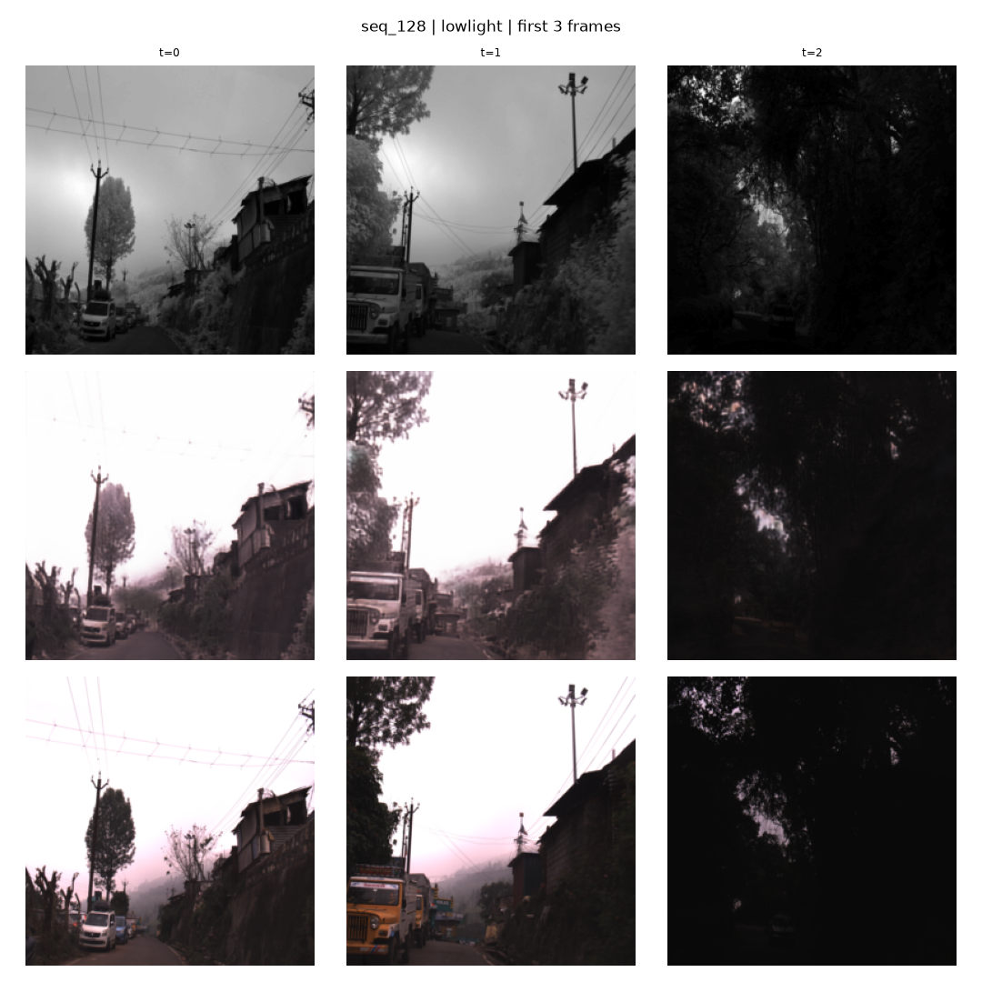

SNOW
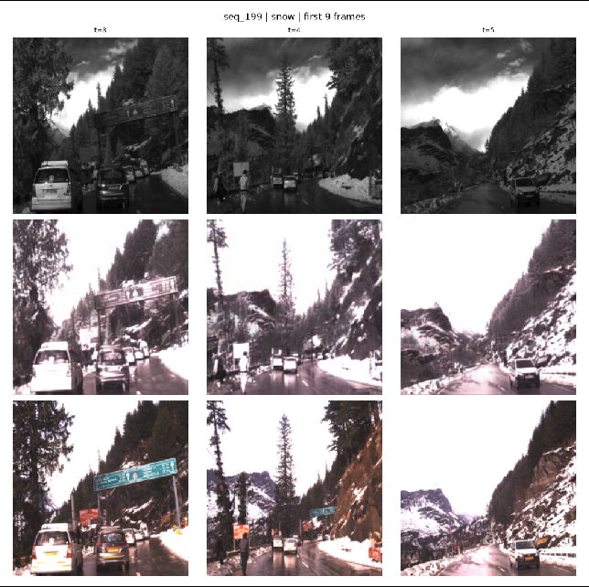
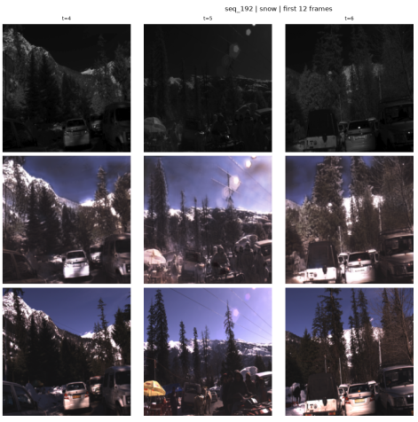
Training on RANUS Dataset

PARAMETERS = 1535250
 | PSNR ↑ | SSIM ↑ | LPIPS ↓ | tLPIPS ↓ | Color Drift ↓ | Flicker Index ↓ | WarpingError TWE ↓ | Training FPS
TempNIR2RGB | 18.42 | 0.74 | 0.359 | 0.366 | 0.062 | 0.09 | 0.114 | 65.45

ABLATIONS:

VARIANT | PARAMETERS | PSNR ↑ | SSIM ↑ | LPIPS ↓ | tLPIPS ↓ | Color Drift ↓ | Flicker Index ↓ | WarpingError TWE ↓ | TrainingFPS
NO GATE | 1387153 | 18.46 | 0.7445 | 0.373 | 0.374 | 0.061 | 0.087 | 0.110 | 71.26
NO CHANGE | 1534733 | 18.68 | 0.7456 | 0.372 | 0.367 | 0.062 | 0.084 | 0.106 | 66.06
NO ALIGN | 1482121 | 18.42 | 0.7387 | 0.396 | 0.360 | 0.052 | 0.083 | 0.105 | 70.29
NO WAVELET | 1450194 | 18.02 | 0.7346 | 0.379 | 0.359 | 0.079 | 0.084 | 0.107 | 69.96
Inference Runtime
Total evaluation time: 9.4s
Frames processed: 584
Average/frame : 16.10 ms
AT INFERENCE:
Variant | PSNR ↑ | SSIM ↑ | LPIPS ↓ | Flicker Index ↓ | TWE ↓ | tLPIPS ↓ | Color Drift ↓ | Ghosting ↓ | FPS ↑ | Latency ms ↓ | Model MB ↓ | Params M ↓ | FLOPs G ↓ | GPU Mem ↓ | RAM ↓
TempNIR2RGB-Lite Final | 18.20 | 0.8008 | 0.295 | 0.091 | 0.115 | 0.353 | 0.07 | 0 | 58.07 | 16.13 | 5.888 | 1535250 | 69.54 | 241.07 | 1597.93
Final w/o Gate | 17.94 | 0.797 | 0.308 | 0.088 | 0.111 | 0.3507 | 0.075 | 0 | 65.24 | 13.99 | 5.32 | 1387153 | 64.69 | 238.74 | 1599.99
Final w/o Change Map | 18.25 | 0.799 | 0.308 | 0.0886 | 0.113 | 0.3508 | 0.071 | 0 | 61.55 | 15.29 | 5.882 | 1534733 | 69.53 | 241.03 | 1606.51
Final w/o Alignment | 17.82 | 0.784 | 0.328 | 0.087 | 0.109 | 0.348 | 0.077 | 1 | 65.03 | 14.34 | 5.68 | 1482121 | 67.8 | 240.25 | 1597.91
Final w/o Frequency Branch | 17.91 | 0.796 | 0.303 | 0.089 | 0.114 | 0.343 | 0.076 | 0 | 67.87 | 14.560 | 5.558 | 1450194 | 66.79 | 229.74 | 1584.33

Sample images:

EVENING:
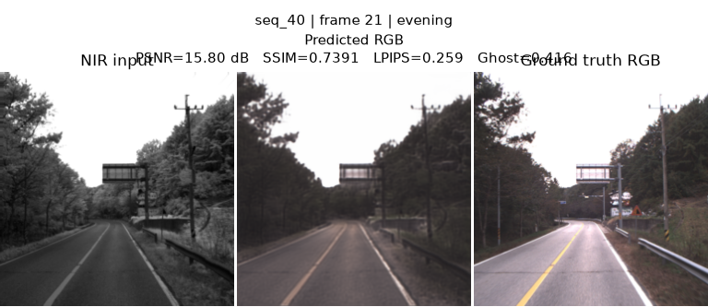
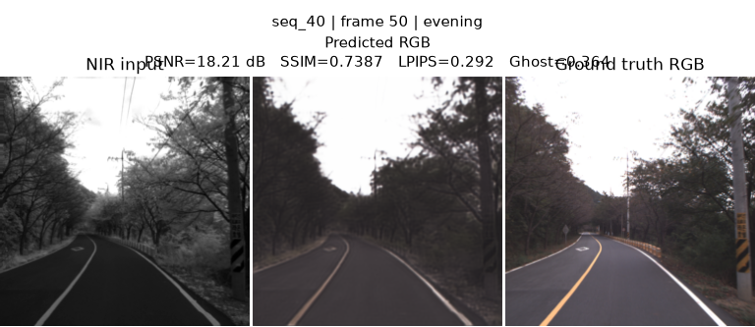

HAZY:
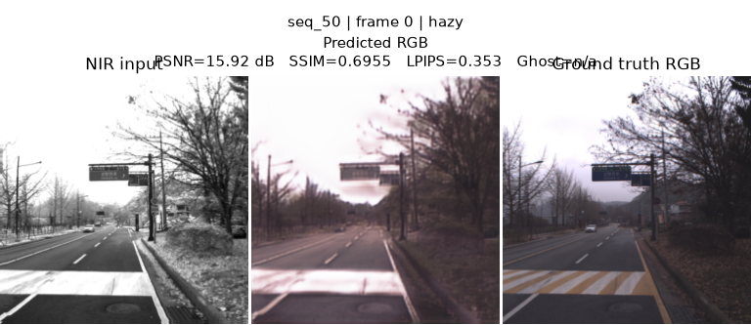
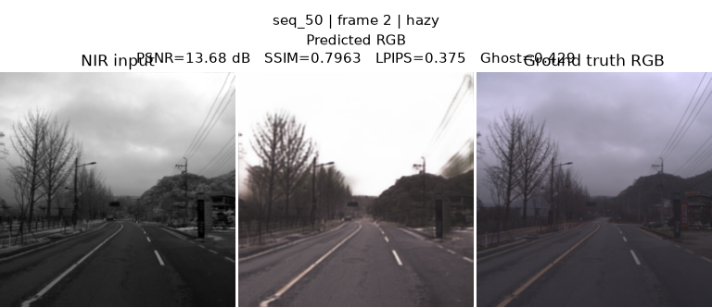

POLLUTED:
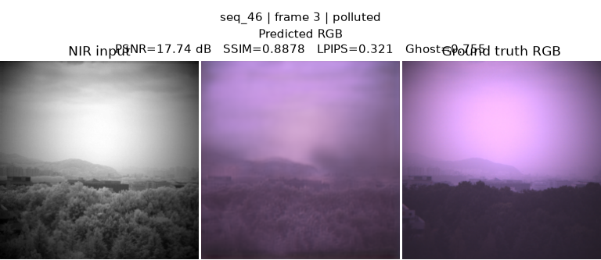
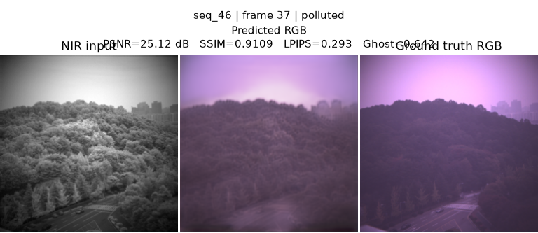

UNKNOWN:
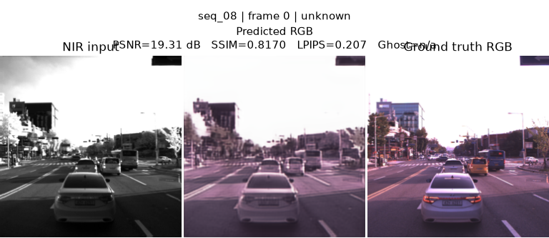
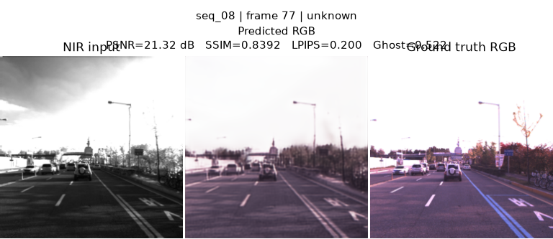

UPDATE 1-
Change Map:
old method: absolute difference
Dt = |x_t - x_t-1|

New method:
NCC (Normalized Cross-Correlation)

- Local Normalized Cross-Correlation dissimilarity map.
- Replaces raw |x_t - x_prev| with a contrast/illumination-invariant measure of local frame-to-frame change:
- NCC(x,y) = local_cov(x_t, x_prev) / (local_std(x_t) * local_std(x_prev) + eps)
- NCC ∈ [-1, 1]; 1 = perfectly correlated (no real change), -1 = perfectly anti-correlated.
- Mapped to a dissimilarity score in [0, 1] via (1 - NCC) / 2 so it's a drop-in replacement for the old abs-diff delta

Unlike raw pixel difference, this is invariant to local brightness contrast shifts, so low-contrast (hazy/polluted) regions don't produce spuriously large "change" purely from sensor/atmospheric noise.

UPDATE 2:
Presprocessing input. Applied CLAHE

VARIANT | PSNR ↑ | SSIM ↑ | LPIPS ↓ | Color Drift ↓ | Flicker Index ↓ | WarpingError TWE ↓ | TrainingFPS
TempNIR2RGB | 18.2096 | 0.8008 | 0.2958 | 0.0701 | 0.0913 | 0.115 | 59.55
NCC+ CLAHE | 18.0066 | 0.7956 | 0.2920 | 0.0750 | 0.093 | 0.1169 | 62.20

TempNIR2RGB
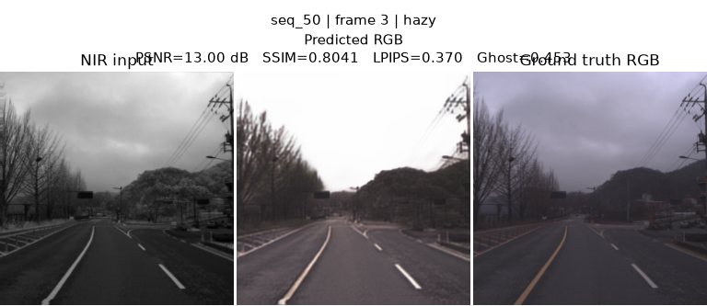

UPDATED TempNIR2RGB
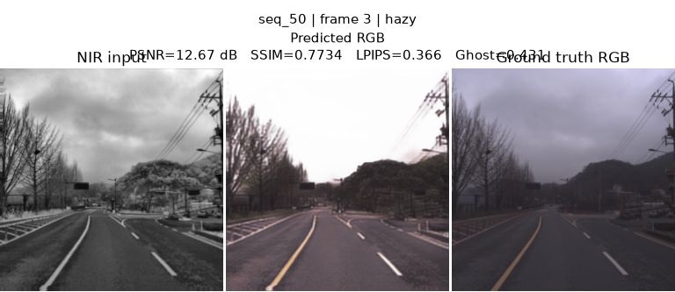

TempNIR2RGB
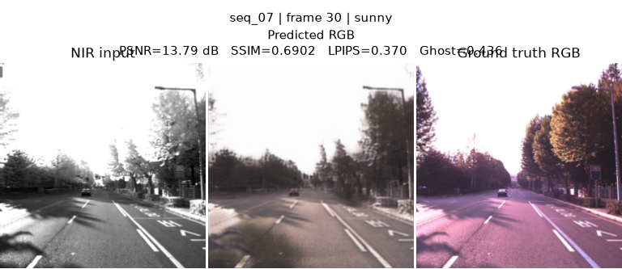
updated
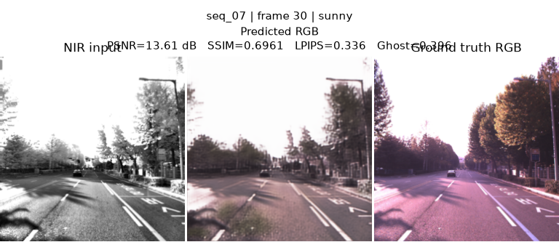

Final ablation table
Fill this exact table. Existing FLAIC values can be used as initial reference, but rerun under final clean protocol.
Variant | PSNR ↑ | SSIM ↑ | LPIPS ↓ | Flicker Index ↓ | TWE ↓ | tLPIPS ↓ | Color Drift ↓ | Ghosting ↓ | FPS ↑ | Latency ms ↓ | Model MB ↓ | Params M ↓ | FLOPs G ↓ | GPU Mem ↓ | RAM ↓
Frame-wise FLAIC | 21.2556 existing / rerun | 0.7174 existing / rerun | 0.2153 existing / rerun | 17.7086 existing / rerun | 50.2943 existing / rerun | 0.4748 existing / rerun | 27.3371 existing / rerun | TO BE RUN | ~69–71 existing / rerun | TO BE RUN | TO BE RUN | TO BE RUN | TO BE RUN | TO BE RUN | TO BE RUN
Alpha Blending | 20.5683 existing / rerun | 0.6788 existing / rerun | 0.2571 existing / rerun | 15.0510 existing / rerun | TO BE RUN | 0.4140 existing / rerun | 23.8277 existing / rerun | 23 existing / rerun | 57 existing / rerun | TO BE RUN | TO BE RUN | same as FLAIC | same as FLAIC | TO BE RUN | TO BE RUN
Previous RGB Conditioning | 22.1436 existing / rerun | TO BE RUN | 0.2119 existing / rerun | 16.9177 existing / rerun | TO BE RUN | 0.4797 existing / rerun | 5.3149 existing / rerun | TO BE RUN | 54.64 existing / rerun | TO BE RUN | TO BE RUN | TO BE RUN | TO BE RUN | TO BE RUN | TO BE RUN
Direct Bottleneck Injection | 21.2556 existing / rerun | TO BE RUN | 0.2153 existing / rerun | 17.4642 existing / rerun | TO BE RUN | 0.4772 existing / rerun | 5.4503 existing / rerun | TO BE RUN | 57.83 existing / rerun | TO BE RUN | TO BE RUN | TO BE RUN | TO BE RUN | TO BE RUN | TO BE RUN
Gated Temporal Memory | 21.1791 existing / rerun | TO BE RUN | 0.2160 existing / rerun | 16.8850 existing / rerun | TO BE RUN | 0.4686 existing / rerun | 21.5285 existing / rerun | TO BE RUN | 46.82 existing / rerun | TO BE RUN | ~62 FP32 existing / rerun | TO BE RUN | TO BE RUN | TO BE RUN | 1.62 GB existing / rerun
GTM + Temporal Loss | TO BE RUN | TO BE RUN | TO BE RUN | TO BE RUN | TO BE RUN | TO BE RUN | TO BE RUN | TO BE RUN | TO BE RUN | TO BE RUN | TO BE RUN | TO BE RUN | TO BE RUN | TO BE RUN | TO BE RUN
TempNIR2RGB-Lite Final | 21.43 | 0.8324 | 0.2657 | 0.1216 | 0.1423 | 0.3970 | 0.0442 | TO BE RUN | 136.48 | 7.33 | ≈2.14 MB | 534,242 | TO BE RUN | TO BE RUN | TO BE RUN
Final w/o Gate | TO BE RUN | TO BE RUN | TO BE RUN | TO BE RUN | TO BE RUN | TO BE RUN | TO BE RUN | TO BE RUN | TO BE RUN | TO BE RUN | TO BE RUN | TO BE RUN | TO BE RUN | TO BE RUN | TO BE RUN
Final w/o Change Map | TO BE RUN | TO BE RUN | TO BE RUN | TO BE RUN | TO BE RUN | TO BE RUN | TO BE RUN | TO BE RUN | TO BE RUN | TO BE RUN | TO BE RUN | TO BE RUN | TO BE RUN | TO BE RUN | TO BE RUN
Final w/o Alignment | TO BE RUN | TO BE RUN | TO BE RUN | TO BE RUN | TO BE RUN | TO BE RUN | TO BE RUN | TO BE RUN | TO BE RUN | TO BE RUN | TO BE RUN | TO BE RUN | TO BE RUN | TO BE RUN | TO BE RUN
Final w/o Frequency Branch | TO BE RUN | TO BE RUN | TO BE RUN | TO BE RUN | TO BE RUN | TO BE RUN | TO BE RUN | TO BE RUN | TO BE RUN | TO BE RUN | TO BE RUN | TO BE RUN | TO BE RUN | TO BE RUN | TO BE RUN
Final FP32 | TO BE RUN | TO BE RUN | TO BE RUN | TO BE RUN | TO BE RUN | TO BE RUN | TO BE RUN | TO BE RUN | TO BE RUN | TO BE RUN | TO BE RUN | TO BE RUN | TO BE RUN | TO BE RUN | TO BE RUN
Final FP16 | TO BE RUN | TO BE RUN | TO BE RUN | TO BE RUN | TO BE RUN | TO BE RUN | TO BE RUN | TO BE RUN | TO BE RUN | TO BE RUN | TO BE RUN | TO BE RUN | TO BE RUN | TO BE RUN | TO BE RUN
Final TensorRT FP16 | TO BE RUN | TO BE RUN | TO BE RUN | TO BE RUN | TO BE RUN | TO BE RUN | TO BE RUN | TO BE RUN | TO BE RUN | TO BE RUN | TO BE RUN | TO BE RUN | TO BE RUN | TO BE RUN | TO BE RUN

